Quarter Report

Name:Xinhang Xu

Data :6/2/2024

It has been three months since I came to UCD. During this period, I mainly focused on the NSTX-U High k Scattering system’s control and monitor.

1. Controlled stepper motors to get maximum CO2 laser power output.
2. Controlled stepper motors to adjust the optical lens position.
3. Monitored the voltage of the CO2 laser power supply.
4. Monitored the laser power and gas pressure.
5. Combined all the monitoring and control systems into one Front Panel and ensured it was working normally.

LabVIEW is the most suitable software to achieve these control and monitoring functions. Temporarily, I have set up the control and monitoring system as shown in figure 1. There are still a lot of optimization needed. We need to rearrange the layout to make them more convenient to use and operating introduction manual script.

Besides this, I also worked with Guanyin on non-thermal electron emission. I benchmarked my electron emission module with theory by calculating the ECE optical thickness and calculated the electron velocity distribution under the evolution of the background environment for Guanyin’s ECE model testing. I also want to finish the kinetic simulation for the anomalous Doppler effect, which could possibly explain the step-structure in ECE signal that I hadn’t finished during my doctoral period.

As for reading, I have read the doctoral thesis of Robert Adam Barchfeld, which helped me understand how the high k system and FIReTIP work. I am now reading the book “Physics of Radio-Frequency Plasmas” written by Chabert, which focuses on plasma physics in nanometer manufacturing. I have also read books such as “LEARN Python in One Day and Learn it Well,” which provides a brief introduction to Python programming. Sometimes, I feel using LabVIEW isn’t the most convenient way to program, if it could be combined with Python code, it would be more easily for handling complex projects, that is what I want to do in the future programming.

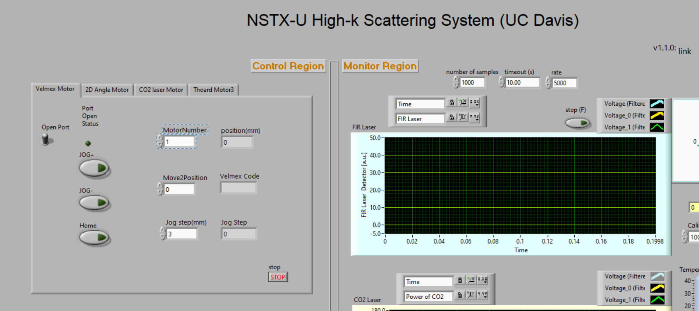

Figure 1 a partial of control & monitoring Front panel screen